PhotoEntry How To

Open PhotoEntry:
https://compent.photoentry.uk/compent/

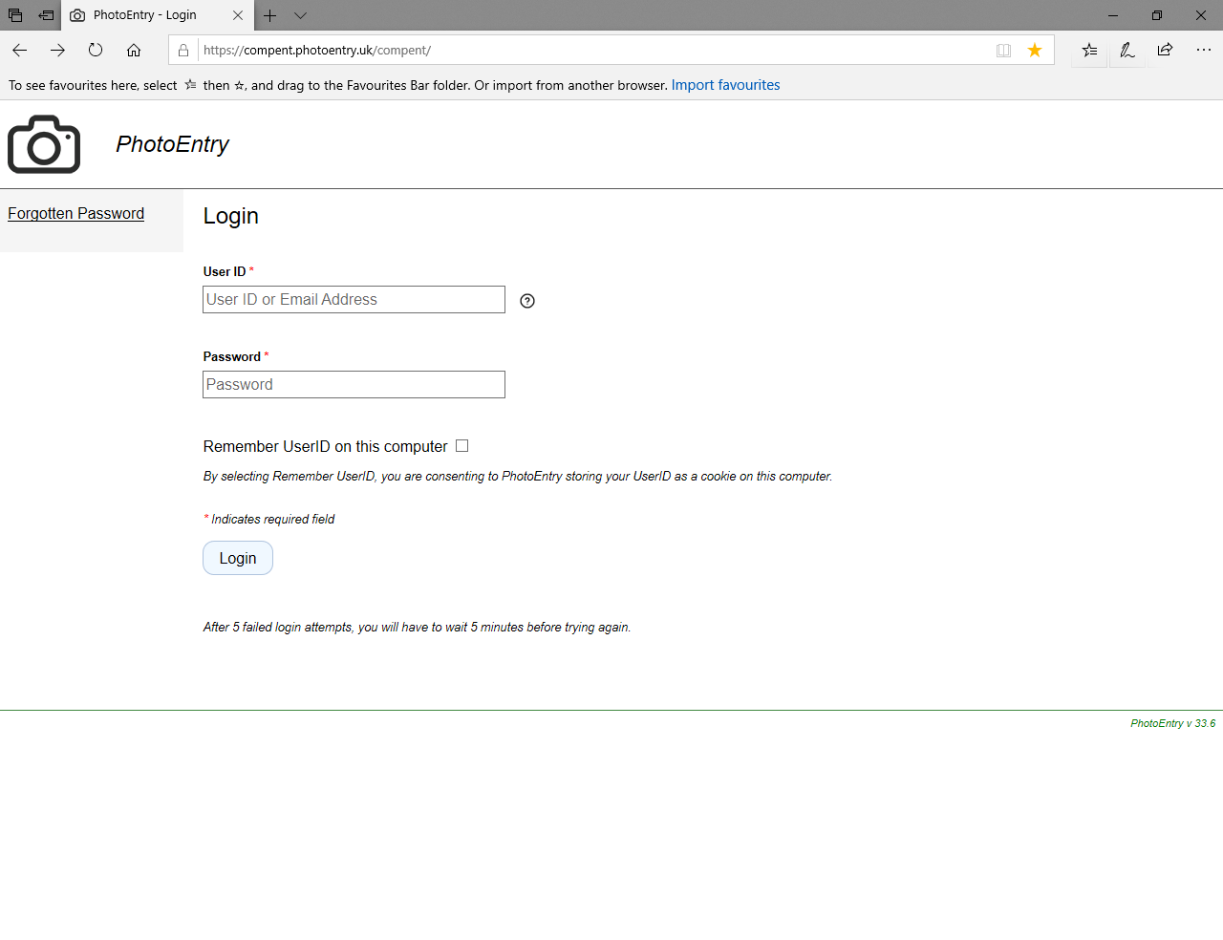

Enter your username, which will be your email address and the password you will have been sent.

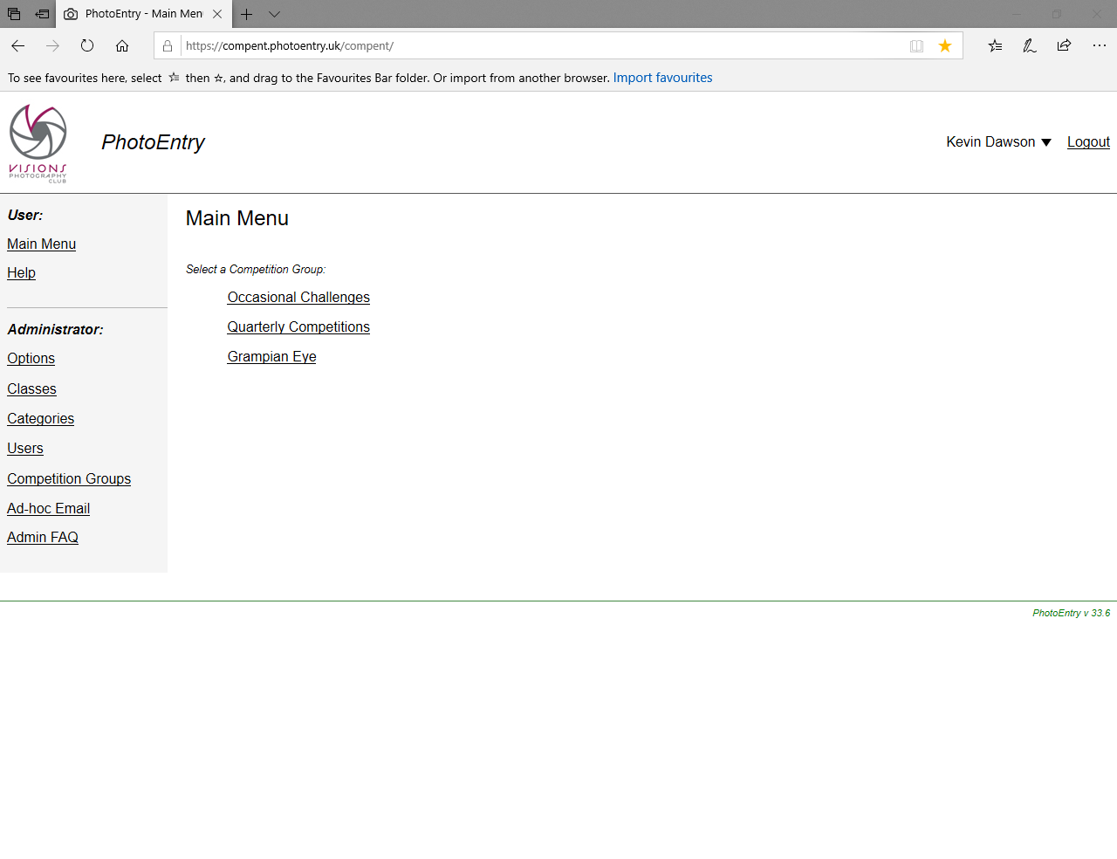

Select Competitions name
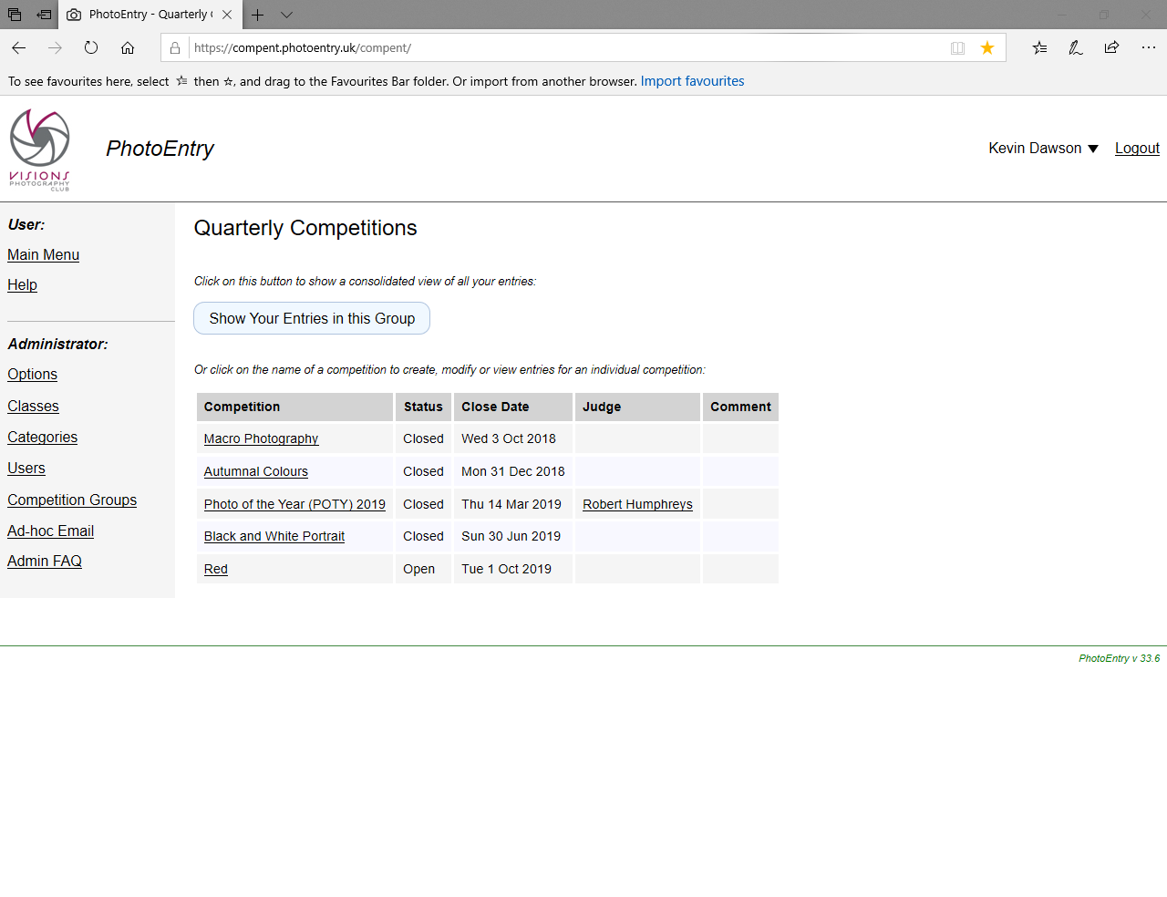
You will be asked to add an entry

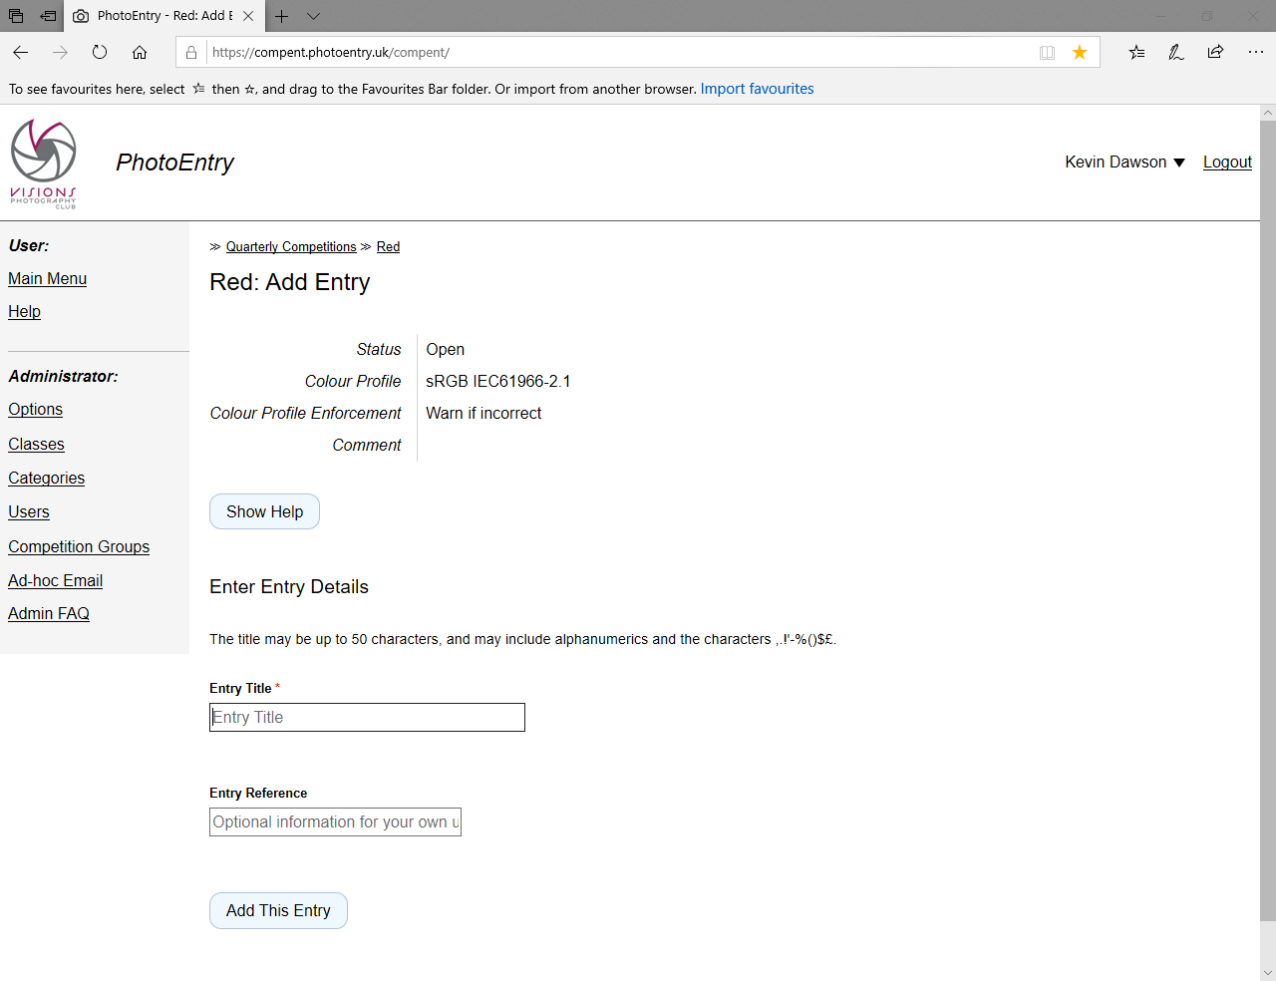

Complete the title on the first page, then submit the image on the next page.

Do not worry if you get an error about having the wrong colour profile. A photo can be saved in sRGB or in Adobe and the system makes us choose one that we want our photos in, however for these competitions it does not matter if you have the other one.

